Unit 9 – Lesson 1. Introduction to N-gram

Aim: What is N-Gram?

Objectives: After the lesson, students should be able to:
- Obtain understanding of N-gram

References:
- Stanford University, N-Grams and SLP
- Columbia University, CS Department, N-Grams and Machine Learning
- CMU, Machine Learning
- Other wonderful online images and simple examples

CLASS PROCEDURE:
Do Now: Fill in the blanks and justify your reason.

A, B, C, D, E, F, G, J, L, M, ______, _______, ________, ________, ________

Class Discussion / Presentation:
- Why do we want to predict a word, given some preceding words?
  - Rank the likelihood of sequences containing various alternative hypotheses
  - Assess the likelihood/goodness of a sentence, e.g. for text generation or machine translation

- What is the algorithm behind the Google Translate?

  - How does Google Translate “detect” the language?

  - How does Google Translate determine the sequence of the words?

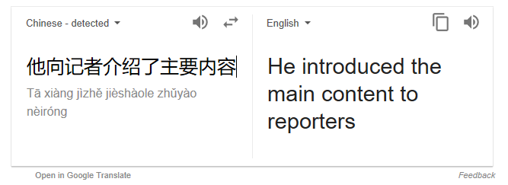

To detect language and determine the sequence of the words, probability and statistics models are applied in “teaching” machine the human languages.

- What is N-gram?
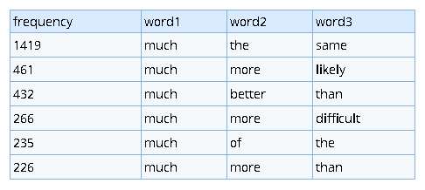
https://www.ngrams.info/

A Ngram, also commonly called an N-gram is a statistical analysis of text or speech content to find n (a number) of some sort of item in the text. It could be all sorts of things, like phonemes, prefixes, phrases, or letters. Although the N-gram is somewhat obscure outside of researcher, it is actually used in a variety of fields, and it has a lot of implications for people making computer programs that understand and respond with natural spoken language.

- What are some of the N-gram examples?

http://www.peachnote.com/#!nt=singleNoteAffine&npq=62+0+1+2+0+-2+-1+-2+-2

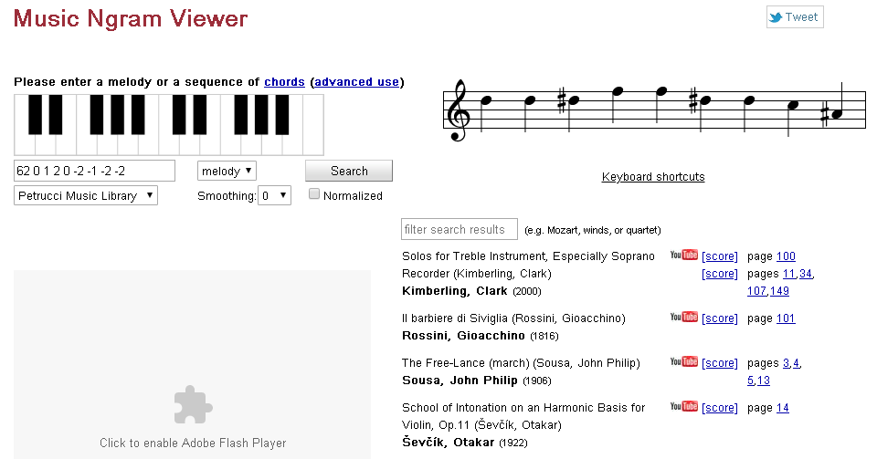

Pair – sharing Practice: Explore the Google N-gram Viewer with your partner
https://www.lifewire.com/google-books-ngram-viewer-1616701

